Room C
CQ1 Rectal Prolapse.
Stem: You are seeing a 60-year-old woman in the office who complains of a tissue protruding from her anus during and after defecation which she manually reduces. She also says she has rectal discharges occasionally, mucus and blood. She denies a history of constipation, stating she can pass stool daily without difficulty. She has had two prior vaginal deliveries. She has no significant previous medical history. Family history negative for colorectal cancer.
Any further infomrations you want?!
- Colonoscopy: 5 years ago.
- Fecal urgency / incontinence? Sometimes, wears a pad.
- Obstetrical Injury? She was told she needed stitches after her first child.
- Any other pelvic organ prolapses (Uterus / bladder?) No, but she feels pelvic pressure and fullness.
What is your Differential Diagnosis?
- Rectal Prolapse.
- Hemorrhoidal prolapse.
- Neoplasm.
- Pelvic organs prolapse.
How are you going to examine her?
-Left lateral or prone Jackknife
- Digital rectal exam / assess Rectal tone.
- Assess the other pelvic organs for prolapse.
(You notice patulous anus, you notice external hemorrhoids but they appear benign, Tone very low. ). Patient tells you, it only comes out when she strains in the bathroom, she now remembers she took a picture? Now what?
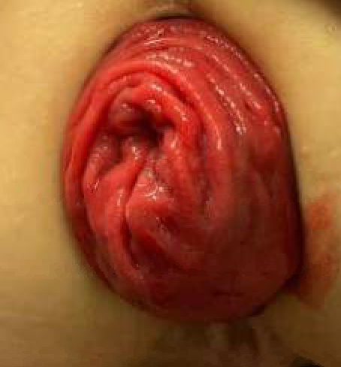
- Exam while sitting on commode: You notice concentric mucosal folds prolapsing, what is your diagnosis ? Rectal Prolapse
How do you differentiate that from Prolapsed hemorrhoids? radial Folds.
Now what’s next?
- Colonoscopy to assess for neoplasia as lead point: Who will do the colonoscopy (Resident must say I will do it) Describe?
- Manometry: Limited role
- Defecography: Why? Can help identify cystocele or vaginal vault prolapse / Allow for combo procedure with GYN.
What would you like to do now? Plan for surgery
How do you counsel the patient about her operative options and risks?
- Preoperative assessment for operative risk: To decide approach.
- Bowel prep
- Perineal Approach (Altemeyer, Delorme)
  - appropriate if multiple prior abdominal operations or poor candidate
  - Higher rates of recurrence
  - Contraindicated if any prior sigmoid or rectal resection.

- Anterior Abdominal approach: What types?
  - Stitch Rectopexy.
  - Resection Rectopexy.
  - Mesh Rectopexy. (Or ventral mesh rectopexy)

When do you offer Resection rectopexy? Sigmoidectomy indicated for patients with constipation.

(Examiner to pick one procedure to describe)

Describe Perineal proctosigmoidectomy?
- Lithotomy or Prone Jackknife position
- Recreate prolapse.
- Make circumferential incision above dentate line.
- Enter the peritoneal cavity through anterior cul-de-sac.
- Deliver the redundant rectum and sigmoid.
- Divide mesorectum/mesocolon.
- Transect colon
- Hand sewn anastomosis.
- +/- levatorplasty if indicated.

Describe a Laparoscopic or Robotic rectopexy?
- Lithotomy position
- port placement
- (If prescribing posterior approach)
  - Enter the posterior mesorectal fascial plane.
  - Avoid hypogastric nerves
  - Mobilize rectum to levators.
  - May divide or spare lateral rectal stalks.
  - Place sutures of rectum to anterior vertebral ligament (Sacral promontory)
- (If prescribing anterior rectopexy)
  - Dissection in the anterior mesorectal plane
  - Enter the rectovaginal space.
  - Mobilize rectum anteriorly all the way to the pelvic floor.
  - Protect the posterior vaginal wall.
  - Place (biologic or prolene mesh)
  - Place sutures of mesh to anterior vertebral ligament (Sacral promontory).
  - Close the peritoneum of pouch of douglas.

Pitfalls:
- Not Performing colonoscopy preop.
- Not checking for other organs prolapse.
- Not attempting to change position to demonstrate the prolapse.
- Not knowing different approaches for repair and indications.

Reference: https://fascrs.org/ascrs/media/files/downloads/Clinical%20Practice%20Guidelines/clinical_practice_guidelines_for_the_treatment_of-3.pdf

CQ2 Penetrating Neck Trauma (Zone II)
Stem: A 22-year-old male sustains a GSW to the neck just lateral to the laryngeal cartilage. Upon arrival, the right side of his neck is swollen. His last vitals reported by EMS are pulse 110, BP 110/75, RR 28.

What is your plan?
Always ABC's
Airway - pt phonating, but raspy
Breath Sounds - bilaterally present
Circulation - peripheral pulse present
Disability - pupils reflexic, moving extremities spontaneously.
Exposure - no other gross abnormalities.
- Neck X-ray - projectile found at midline at same level of entry wound (lateral if obtained has projectile anterior to C₅ body
- CXR - normal

How would you manage this patient? (2 options)
1) Zone II neck exploration
Incision at anterior border of sternocleidomastoid muscle
Explore carotid and esophagus for injury.

Esophageal injury found. What is your plan?
2-layer closure and leave drain.
2) Selective management
Hematoma of neck prompts work-up
- CT angiography of neck - no carotid injury.
- (Plus) Esophageal work-up UGI of cervical esophagus.

There is a question of injury? Now What?
- Rigid esophagoscopy (not flexible for cervical esophagus - this results in missing injury)
- Or exploration.

Esophageal injury found. What is your plan?
2-layer closure and leave drain.

What if patient presented with same injury, but without swelling/hematoma?
Distal carotid pulse (submandibularly) should be confirmed - Normal.
CTA neck - No injury
UGI of cervical esophagus - No injury
(Resident must also examine unilateral extremity for evidence of nerve root injuries)

Pitfalls:
- Not performing both CTA and UGI.
- Not exploring when UGI is questionable.
- Knowing how to use rigid proctoscopy.
- Knowing how to repair.
- Knowing to do upper extremity neurochecks.

References : https://www.ncbi.nlm.nih.gov/books/NBK470422/

CQ3 DCIS / LCIS / Ductal Papilloma
Stem: 55y postmenopausal female is referred to the office for calcifications seen in the upper outer quadrant of the right breast on annual screening mammogram that weren’t appreciated on the mammogram the year prior. She denies any changes in her breasts or axillae.
PMH/PSH: None
Family history is negative for breast or gynecologic malignancies.
Physical exam is unremarkable.

What is your Differential Dx?
- DCIS
- LCIS
- Invasive breast cancer
- Atypical ductal or lobular hyperplasia
- Fibrocystic changes
- Fat necrosis

Additional Workup or Studies?

- Diagnostic mammogram
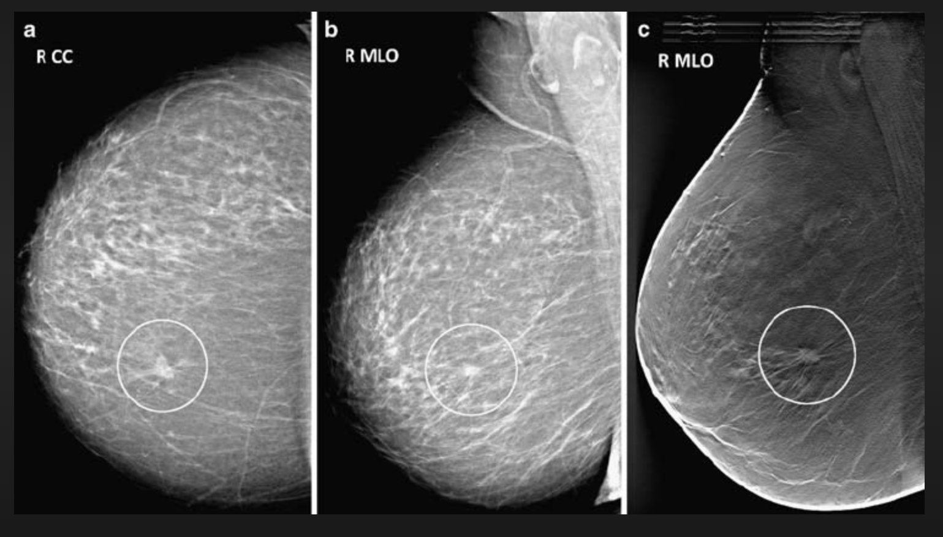

reveals fine linear branching calcifications of the right breast; the calcifications appear focal and do not appear to be multicentric.

- Stereotactic core needle biopsy returns as DCIS

What would you like to do now?
- Surgery:
    - Localization
    - Breast conserving surgery with postoperative radiation (no SLNB)
    - (or) Simple mastectomy with sentinel lymph node biopsy +/- reconstruction

Pathology returns as ER/PR + high grade DCIS, what treatment you would recommend ?
5 years of anastrozole

Scenario 1: Same patient, but core needle biopsy returns as LCIS (ER/PR +, HER2/neu negative). You proceed to OR for excisional biopsy, Pathology returns LCIS, positive inferior margin.

What would you like to do now?

- Observation:
- H&P q6 months x5y
- Mammogram in 6 months then annually
- Anastrozole or raloxifene

- bilateral prophylactic mastectomy +/- reconstruction, however usually reserved/recommended for patients with strong family history and/or high genetic risk.

(Pitfall: Examinee should recognize that LCIS is a marker of increased risk but not an actual precursor lesion therefore -no tumor on ink- does not apply.)

Scenario 2: Different 55y. postmenopausal female presenting with complaints of unilateral bloody nipple discharge from the left breast. Mammograms are unremarkable.
What would you like to do now?

- Ultrasound vs MRI vs contrast ductography: US demonstrated a dilated duct in the left periareolar area
- Ultrasound guided biopsy: indeterminate
- OR: Terminal duct excision/excisional biopsy
  - Insert a fine lacrimal duct probe into the dilated duct.
  - Make a periareolar incision (no more than 30% circumference).
  - Isolate the affected duct and resect the subareolar region with the abnormal duct attempting to preserve unaffected duct(s) if possible.
- Pathology: intraductal papilloma.

Reference: https://www.annalsofoncology.org/article/S0923-7534(19)31287-6/fulltext

